

Anypoint Studio

Setup

February 15, 2017

**Document Control Information**

**Document Information**

|  |  |
| --- | --- |
| **Name** | Anypoint Studio Setup |
| **Program Name** | Enterprise Integration |
| **Author** | P M Arjun |
| **Version** | 1.0 |
| **Status** | Draft |

**Document Edit History**

|  |  |  |  |
| --- | --- | --- | --- |
| **Version** | Date | Description | Author |
| 1.0 | 13/02/2017 | Initial | P M Arjun |
|  |  |  |  |
|  |  |  |  |
|  |  |  |  |
|  |  |  |  |
|  |  |  |  |

**Support / SME Resources**

|  |  |  |  |
| --- | --- | --- | --- |
| **Team** | Name | Role | Contact (Email / Phone) |
|  |  |  |  |
|  |  |  |  |
|  |  |  |  |
|  |  |  |  |

Contents

1. Introduction 4

2. Software and Hardware requirements 4

3. Download And Install Anypoint Studio 5

4. Important Plugins to Install and its Uses 7

1. Introduction

Anypoint Studio is MuleSoft Eclipse-based integration development environment for designing and testing Mule applications. You can deploy the application and run it on your Mule server. This document briefs about from where to download, install and setup Anypoint Studio IDE. Setting up a proper development environment is crucial for a successful use of the Mule Runtime. The following document outlines the steps to be taken before any significant use of Anypoint Studio, Mule, and Cloud solutions.

1. Software and Hardware requirements

| **Hardware Requirements:** | |
| --- | --- |
|  | * 4GB of free memory available * 2GHz CPU * 10GB free hard drive space |
| **Software Requirements:** | |
| **Java Environments** | * Oracle JDK 1.8 * Oracle JDK 1.7.0 (recommended: [JDK 1.7.0_79/80](http://www.oracle.com/technetwork/java/javase/downloads/java-archive-downloads-javase7-521261.html#jdk-7u80-oth-JPR)) - **Note**: If you install Anypoint   Studio on a new MacOS computer, you also need to install [JRE 1.6](http://www.oracle.com/technetwork/java/javase/downloads/java-archive-downloads-javase6-419409.html) |
| **Operating Systems** | June 2015 and newer:   * MacOS 10.10.0 * Windows (32- and 64-bit) Windows 7, Windows 8, Windows 10 * RHEL 7.0 * Ubuntu Server 14.04 |

1. Download And Install Anypoint Studio

Please follow the below steps to download and install Anypoint Studio:

1. Install Anypoint Studio IDE version 5.x or higher in your local machine.

Download studio from below link: (If not working in normal network, try it after connecting to VPN).

<https://www.mulesoft.com/platform/studio>

1. Once download is completed, go to the folder where you have downloaded the studio.

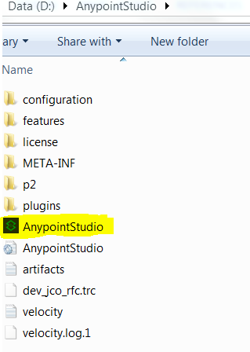

Open the Anypoint application file. You will be prompted to choose a workspace.

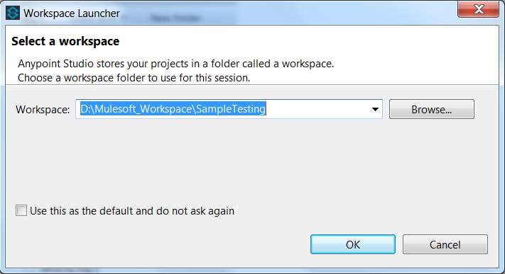

You can create your own workspace, which would have your projects.

1. Once Anypoint studio is downloaded, open Anypoint studio. First make sure your IDE should be using JAVA_HOME. For this go to window menu bar and select preferences. Then select Java and installed JRE and provide the path of JAVA_HOME.

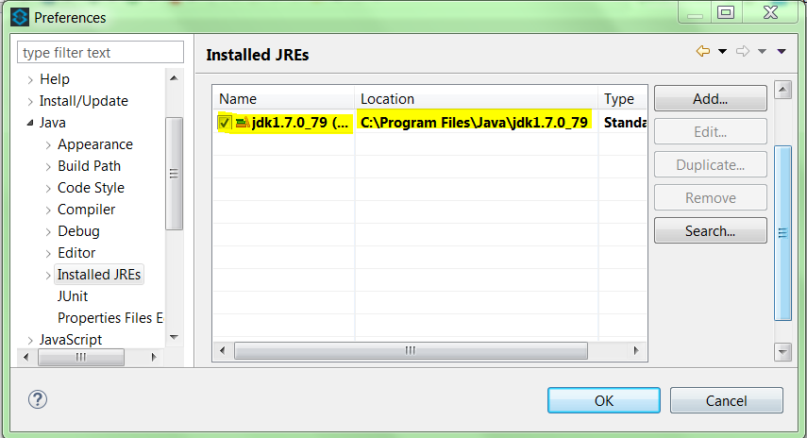

1. Install Mule Runtime 3.7.1 or higher in Anypoint Studio IDE.

For this select Help menu then go to Install New Software’s option and select the URL which is shown in below screenshot and install the mule runtime version based on application requirement.

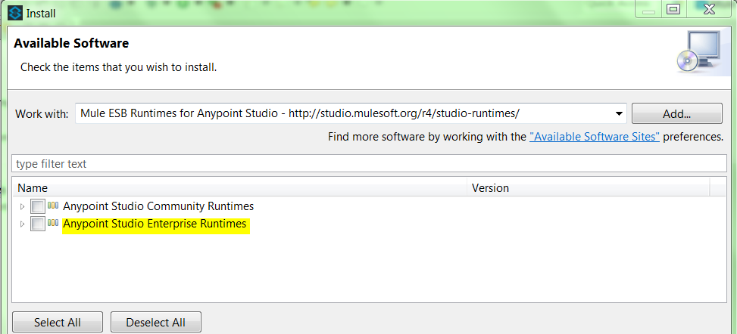

Developer can select the higher version of Mule Runtime 3.8.3.

1. Install Maven 3.x or higher in local system.

For more details please refer below attached document.



1. Now once your maven is installed and configured with Anypoint studio IDE, you can still add maven support to an existing project by ‘Mavanizing’ it:

a. Right-click the name of your project in the Package Explorer.

b. Select Mule > Mavenize.

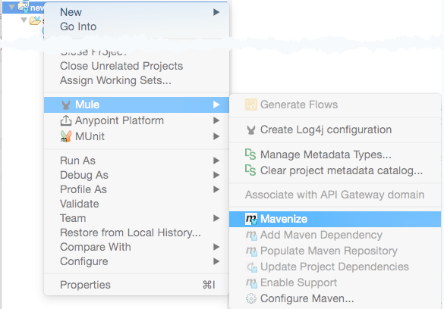

Studio presents a confirmation dialog, warning that although Maven support can later be disabled, this does not reset your project’s classpath. Click yes to confirm.

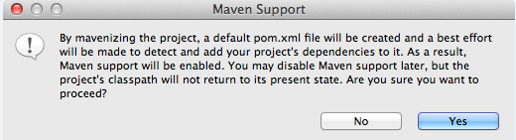

Studio creates a pom.xml file for your project. You can observe the progress in the console.

When the mavenization process is complete, the pom.xml file for your project appears in the Package Explorer underneath the mule-project.xml file.

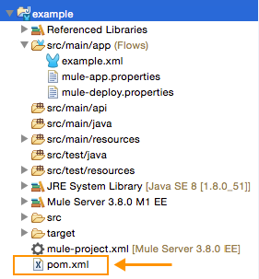

1. If you have created Maven project in Studio and wish to disable Maven support for that particular project, right-click the project name in the **Package Explorer**, then select **Mule** > **Disable Support**.

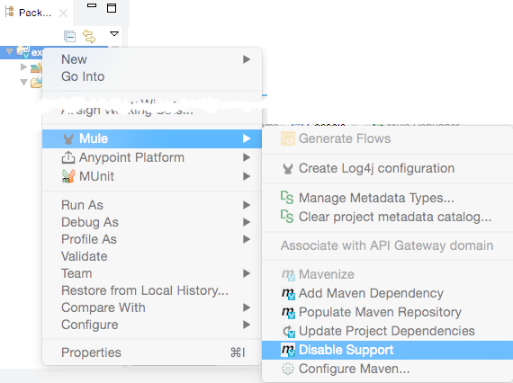

1. You can import a maven project as shown below:

a. In Studio, go to File > Import…

b. Select Mule > Maven-based Mule Project from pom.xml, then click Next.

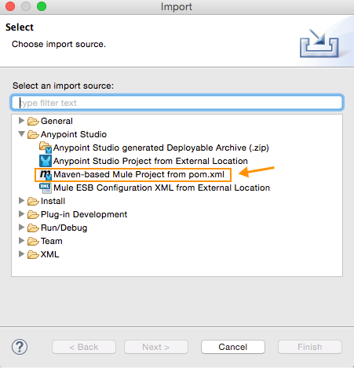

c. Navigate to the location of the pom.xml file you wish to import. Mule automatically populates a Project Name, but you can adjust it.

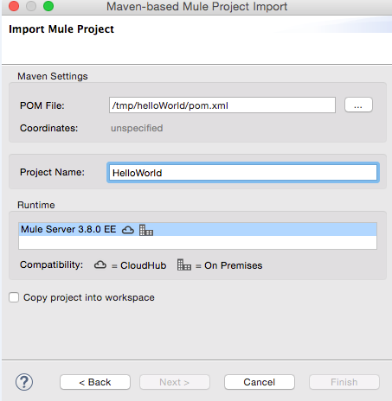

d. Be sure to select the runtime you wish to use. Check Copy project into workspace if you want to create a copy of your project that resides in your workspace.

e. Click Finish.

1. You can also package your Mule project from the command line by executing the following syntax:

mvn package

The maven-mule-plugin packages the project in a .zip file and places it in a /target folder. Copy the .zip file to the apps folder of your standalone Mule instance to run the application.

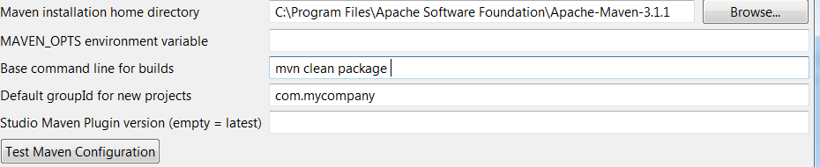

1. Important Plugins to Install and its Uses

* **Secure Property Placeholder: -**

Secure property placeholder is used to encrypt/decrypt the properties like username, password, access keys, secret keys etc. By default, this plugin is installed in mule studio but for using we need to install a Mule properties editor.

1. Install the Mule properties editor plugins.

URL: - <http://studio.mulesoft.org/r4/devkit>

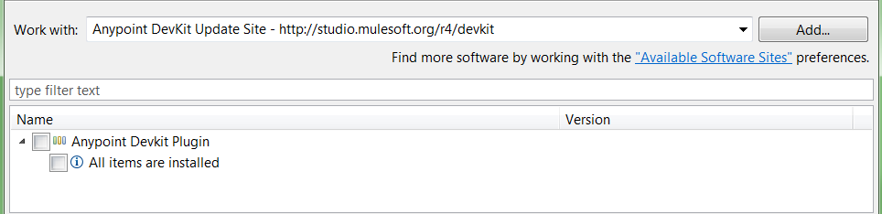

1. After installation of the plugins we can open any property file by using Mule properties editor.

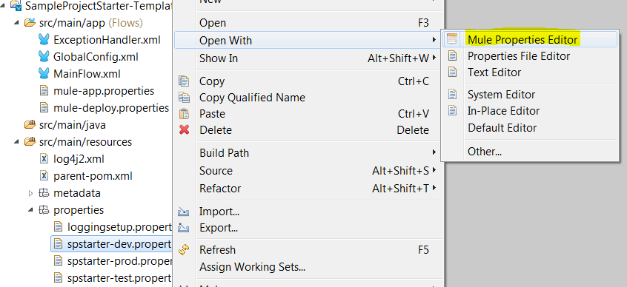

1. Now we can see, there are two tabs table editor and text editor.



We need to select the Table editor for securing properties. By using this table editor we can add, encrypt and decrypt the properties based on several algorithms which were supported by mule.

1. First we need to configure the below config as global configuration.

<secure-property-placeholder:config

name=*"Secure_Property_Placeholder"*

encryptionAlgorithm=*"Blowfish"* key=*"${key}"*

location=*"properties/spstarter-${env}.properties"* doc:name=*"Secure Property Placeholder"* />

The “env” and “key” values will be declared in mule-app.properties.

“env” contains the dev/test/prod environment

“key” contains custom value which is required for encryption/decryption of properties

1. Let us suppose we want to encrypt the “Access Key” value in property file. Double click on the property row, a new window will open which ask for to encrypt the value.

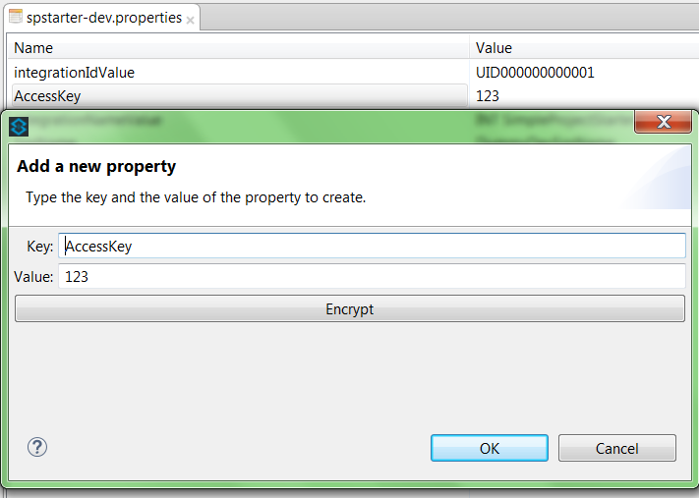

1. Now select the Encrypt button then a new window will open where we need to provide the provide the key which have declared in mule-app.properties and the encryption

Algorithm which we want to use. There are several algorithm which mule supports like Bluefish, Twofish, AES,DES, RSA etc.

In this case we are using Bluefish algorithm and key which we declared in mule-app.properties.

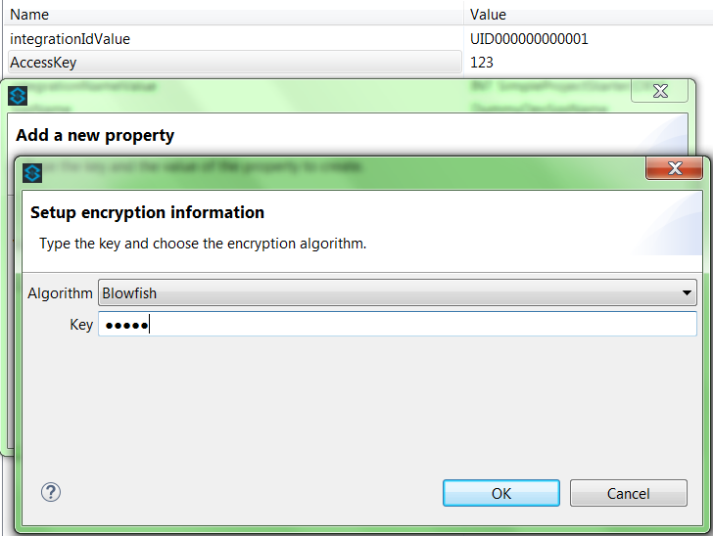

1. Now select the ok to encrypt the key.

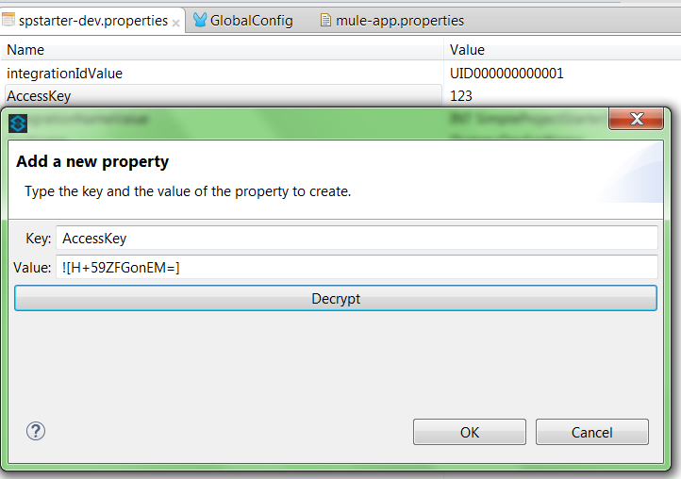

1. Now click Ok to place encrypted value in the properties file.

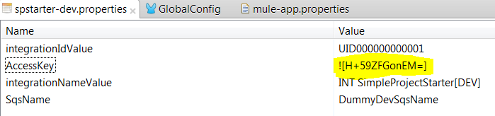

1. In the same way, we can work for decryption as well. Double click on the property which we want to decrypt. A new window will appear.

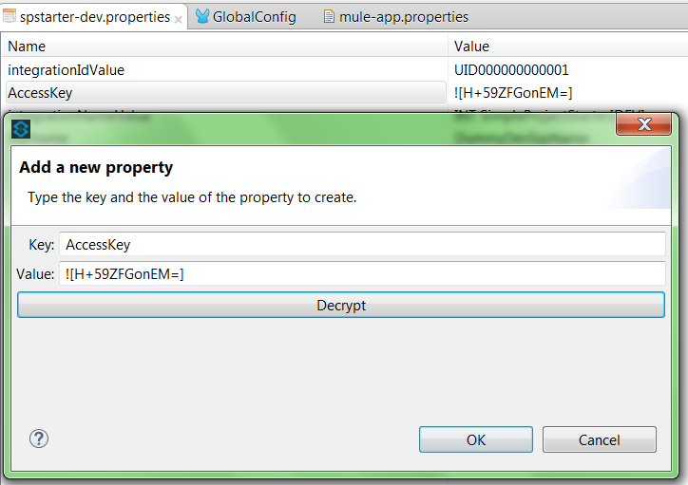

1. Then select decrypt, to see the original value of the properties.

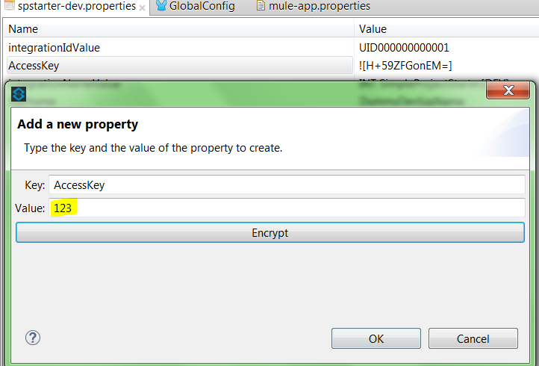

* **JSON Editor:-**

To avoid the syntax errors and data formation errors in while with json we need to install the JSON editor plugins in studio.

Url :- <http://boothen.github.io/Json-Eclipse-Plugin/>

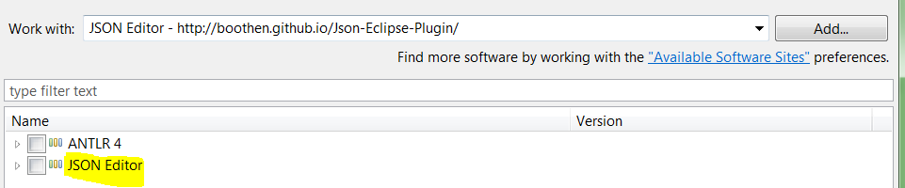

* **Munit:-**

Munit is default available with studio, but if it not available then we can install it. Munit basically used for unit testing of the mule flows.

Url:- <http://studio.mulesoft.org/beta/r5/munit>

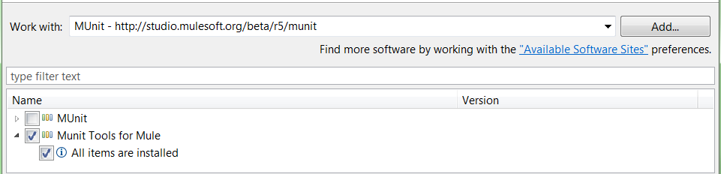

* **SVN:-**

SVN plugin is required for developer for doing check in and check out.

Url :- <http://subclipse.tigris.org/update_1.10.x>

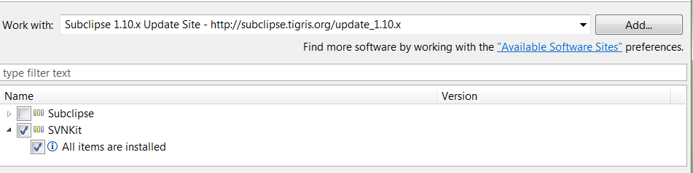

After installation, we can use SVN by following below steps:-

1. For using SVN, VPN Connection is mandatory.
2. In Anypoint Studio IDE, type svn in right most top search box



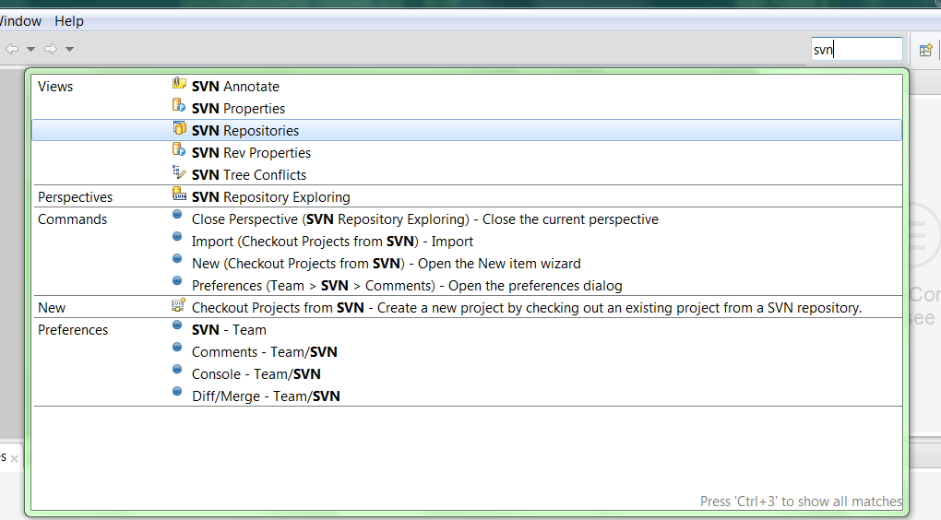

1. Now select the SVN Repositories, after this we can see a svn window will open.
2. Now we need to add the SVN repo location, for this right click on mouse and then

Select New to add Repository Location.

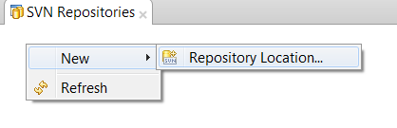

1. Now a new window will appear then provide the svn repo location and click finish.

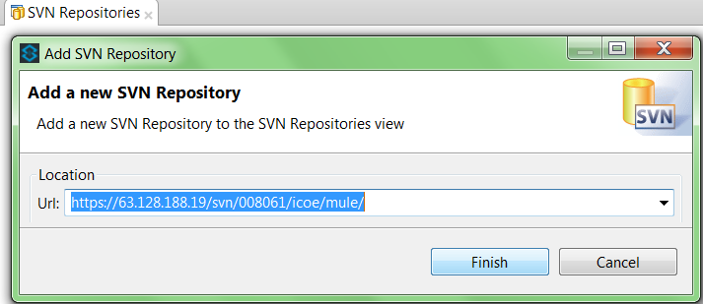

It will ask for credentials while accessing this url.

Note: - So make sure we should have svn login access before doing this activity.

1. Now we can see url which requested will appear. Now select the option which is arrowed.

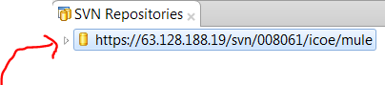

1. Now we can see multiple available project which are in svn.

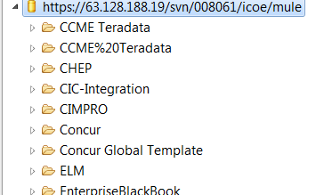

1. In the same way, we need to select options for the project which we want to

checkout. Suppose we select the below application and we want to check out.

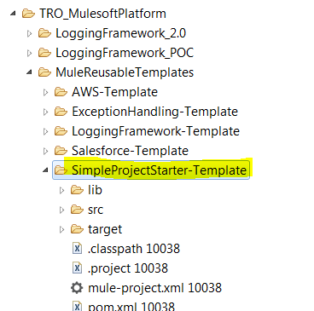

1. Right click on mouse button and then select checkout.

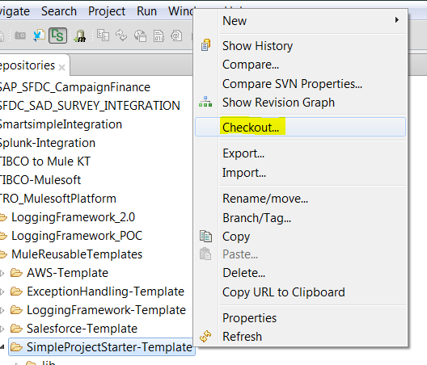

Then it will start downloading the project from remote location.

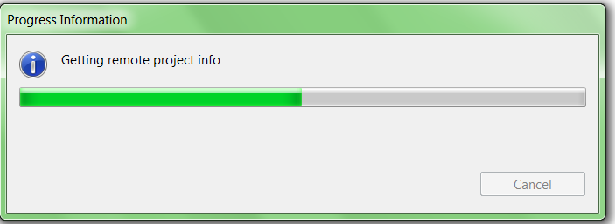

1. After a new window, will appear, then provide information and click next and then finish.

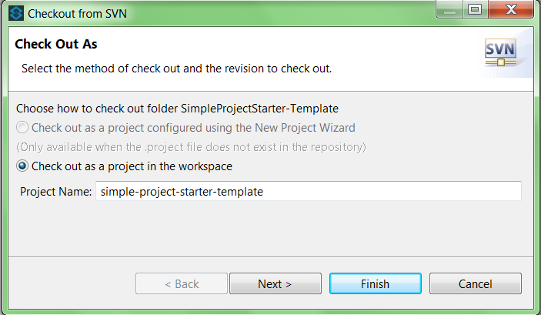

1. Now the checkout process will start and the project will be available in the workspace.

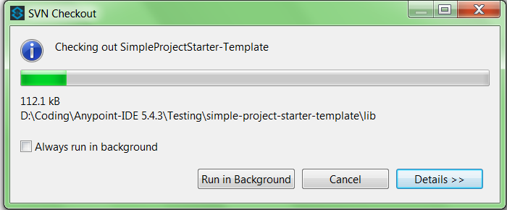

1. The project will appear in workspace as below.

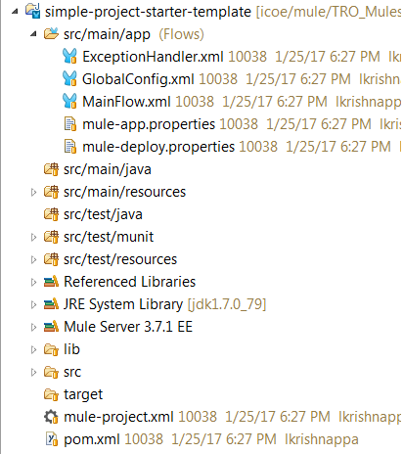

For doing check-in and all other operations this svn plugin will work

Note: -

1. Developer should have some basic understanding of SVN.
2. We can also use Tortoise SVN tool instead of using this studio svn plugin.

Url :- <https://tortoisesvn.net/downloads.html>

* **Anypoint Connectors:-**

Anypoint Connectors provide the connectivity between the different systems.

Url :- <http://repository.mulesoft.org/connectors/releases/3.5.0>

Depends on requirement developer can install the connectors from above link

Let us suppose we need to install twitter connector, and then enter url and type twitter in the search box, available connectors will appear.

